**Steps to Install SAP WebIDE Personal Edition and Connect to R4E**

**Prerequisites**:

You have installed Java™ Platform, Standard Edition Runtime Environment (JRE) Version 7 (at least version 1.7) or Version 8 in the 64-bit version. If required, download an installer from [Java SE Download](http://www.oracle.com/technetwork/java/javase/downloads/index.html) Information and follow the instructions.

**Procedure**

1. Go to [SAP Development tools](https://tools.hana.ondemand.com/#sapui5).
2. Select the SAPUI5 tab and scroll down to SAP Cloud Platform Web IDE personal edition.
3. Download the installation ZIP file.

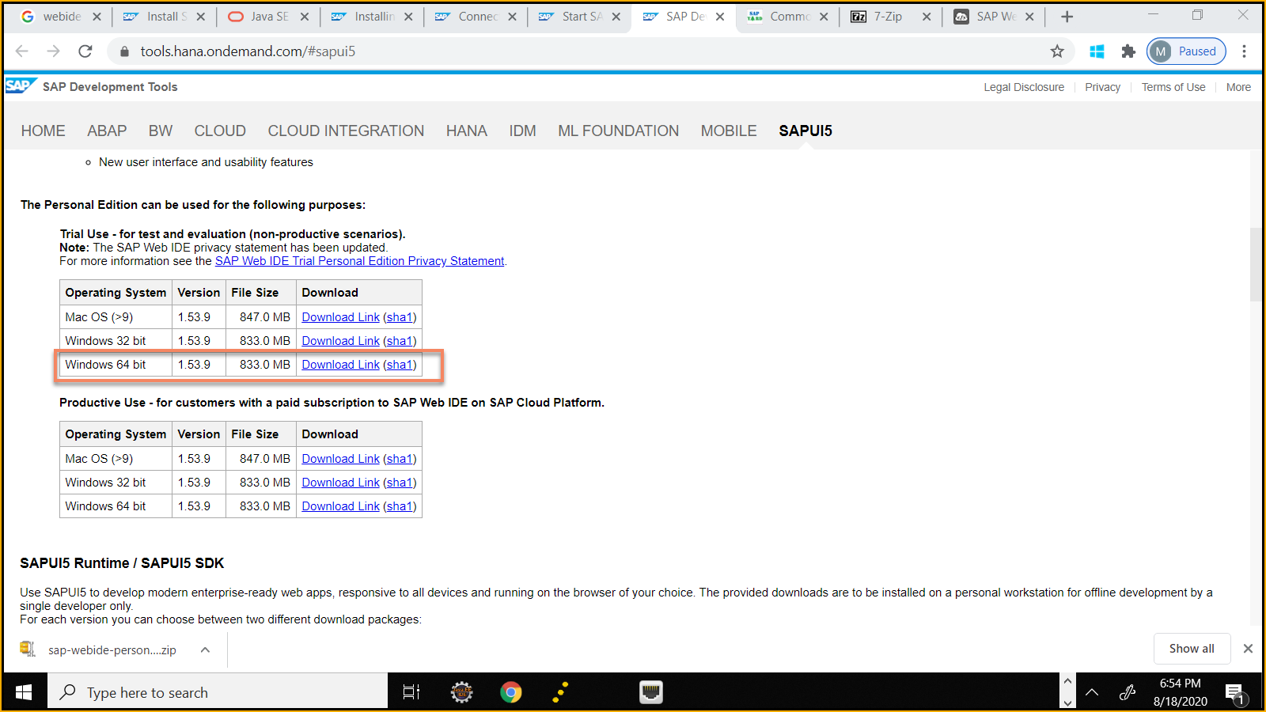

1. Create a new folder in C Drive. Name it SAPWebIDE.

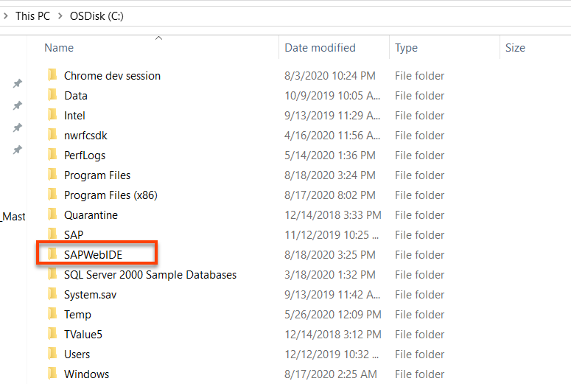

1. Extract the zipped files to C:\SAPWebIDE.

**Due to the long file names, you might have problems extracting the files. Make sure you use a ZIP program that can handle long file names. I used 7-ZIP software as WINZIP had issues.**

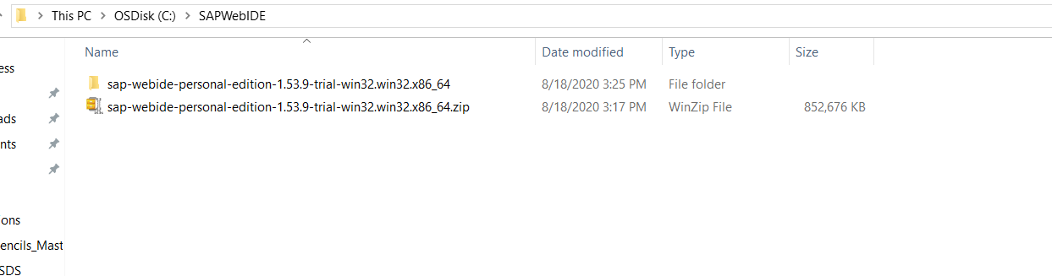

1. Since the server is part of the installation, you must first open Orion. Start the Orion Application Server as follows:
   1. Go to C:\SAPWebIDE and open the eclipse folder.
   2. Double-click the orion.exe file.

A command shell opens.

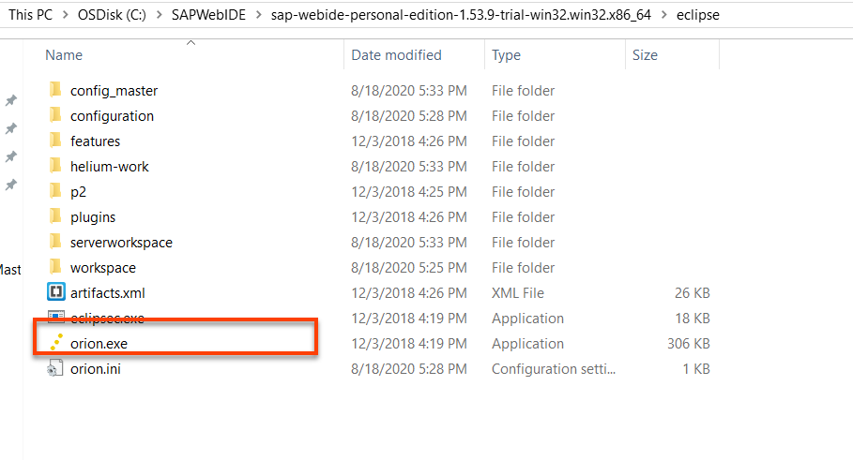

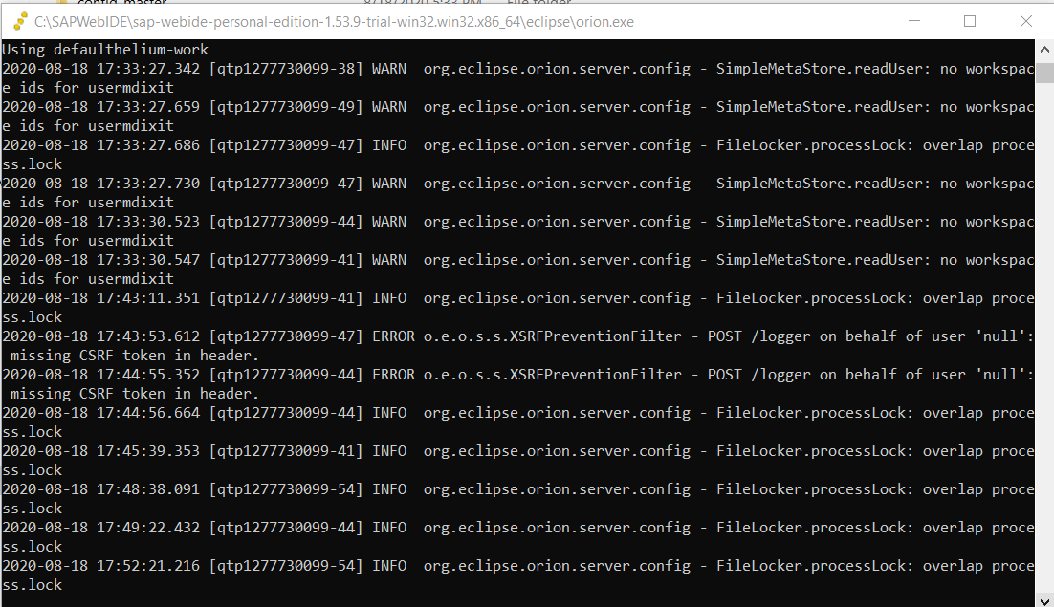

1. Access SAP Web IDE personal edition via the URL http://localhost:8080/webide/index.html

The default port is 8080. If you configured a different port, you must change it in the URL accordingly

1. When you start the Orion Application server for the first time (after initial installation or upgrade), you have to create a new account for it. (In the future this might be done automatically.)

Choose Create a new account.

Enter a user-name and password.

SAP Web IDE personal edition does not support more than one account.

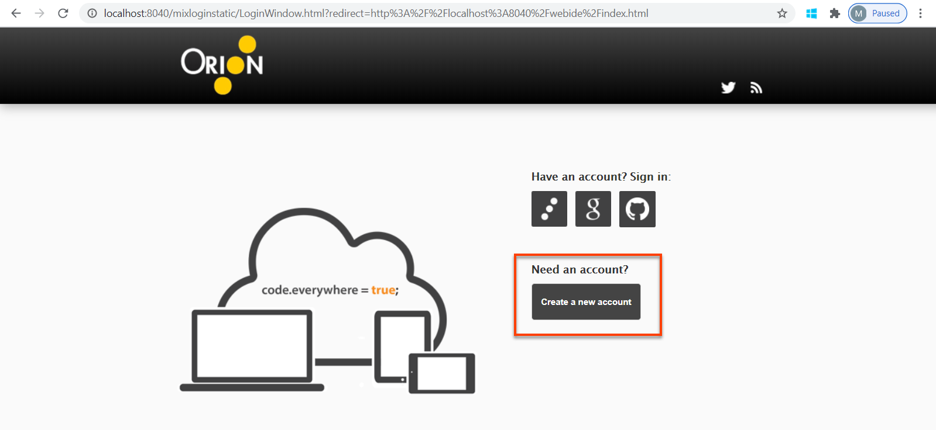

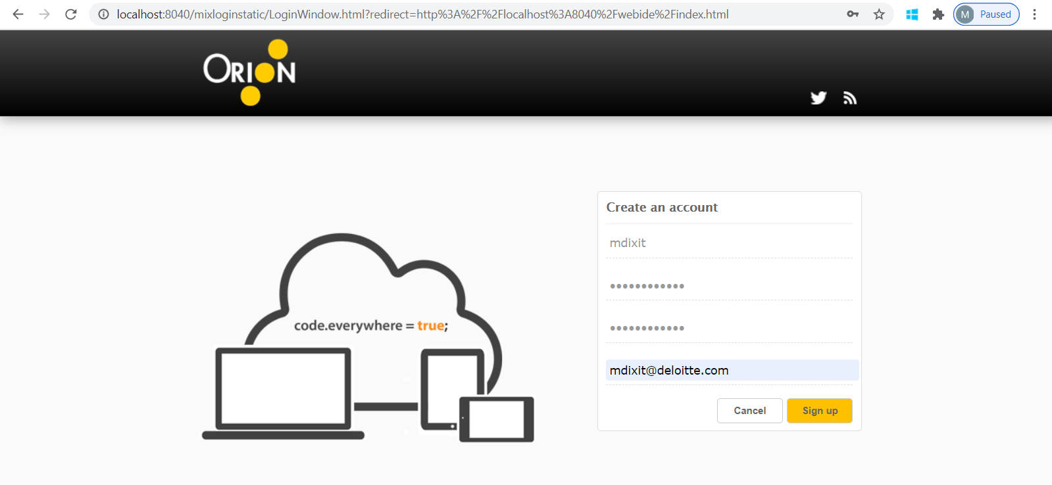

1. Your local WebIDE will be loaded.

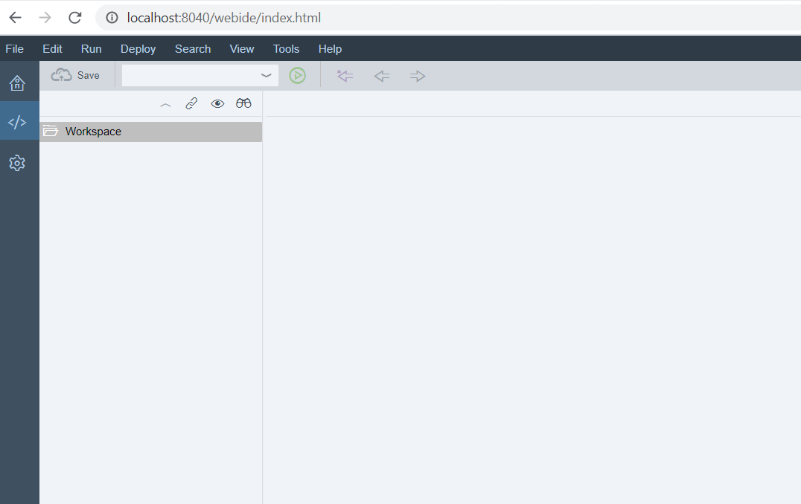

1. To connect to backend SNET system, make sure you are connected to Deloitte VPN.

Go to “C:\SAPWebIDE\sap-webide-personal-edition-1.53.9-trial-win32.win32.x86_64\**eclipse**\**config_master\service.destinations\destinations**”

And create a destination file. Destination file for R4E is shared with this tutorial.

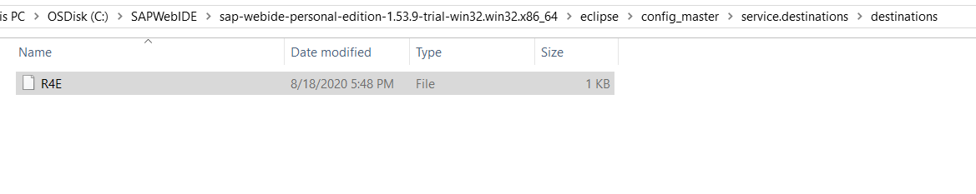

1. Go to Web IDE to test the connections. Click on File -> Import -> Application from SAPUI5 Repository. You should see the R4E Applications loaded.

